Shipment Data Cleaning Project using BigQuery
Project Overview
This project focuses on cleaning and validating a logistics shipment dataset using SQL in BigQuery. The dataset contains shipment records with multiple data quality issues such as:
- Duplicate records
- Missing values
- Inconsistent text formatting
- Invalid dates
- Negative shipment weights
- Incorrect delivery timelines
- Mixed capitalization
The goal of this project is to simulate a real-world data cleaning workflow used by data analysts and data engineers before performing reporting or analytics.

Dataset Information
File Name
dirty_shipments.csv
Total Records
25 rows
Columns
Column Name | Description
shipment_id | Unique shipment identifier
origin_warehouse | Shipment source warehouse
destination_city | Destination city
destination_state | Destination state
carrier | Shipping company
ship_date | Date shipment was dispatched
delivery_date | Date shipment was delivered
weight_kg | Shipment weight
freight_cost | Transportation cost
shipment_status | Current shipment status
items_count | Number of items
damage_reported | Whether damage was reported

Project Objectives
This project will help you learn:
- Detecting duplicate records
- Handling NULL values
- Standardizing categorical values
- Validating date logic
- Cleaning numerical columns
- Creating clean analytical datasets
- Generating operational insights

Step 1 — Load the Dataset into BigQuery
CREATE OR REPLACE TABLE logistics.dirty_shipments (
shipment_id STRING,
origin_warehouse STRING,
destination_city STRING,
destination_state STRING,
carrier STRING,
ship_date STRING,
delivery_date STRING,
weight_kg FLOAT64,
freight_cost FLOAT64,
shipment_status STRING,
items_count INT64,
damage_reported STRING
);

Small Level Data Cleaning Questions
Question 1 — Find Duplicate Shipment Records
SQL Query
SELECT shipment_id,
COUNT(*) AS duplicate_count
FROM logistics.dirty_shipments
GROUP BY shipment_id
HAVING COUNT(*) > 1;
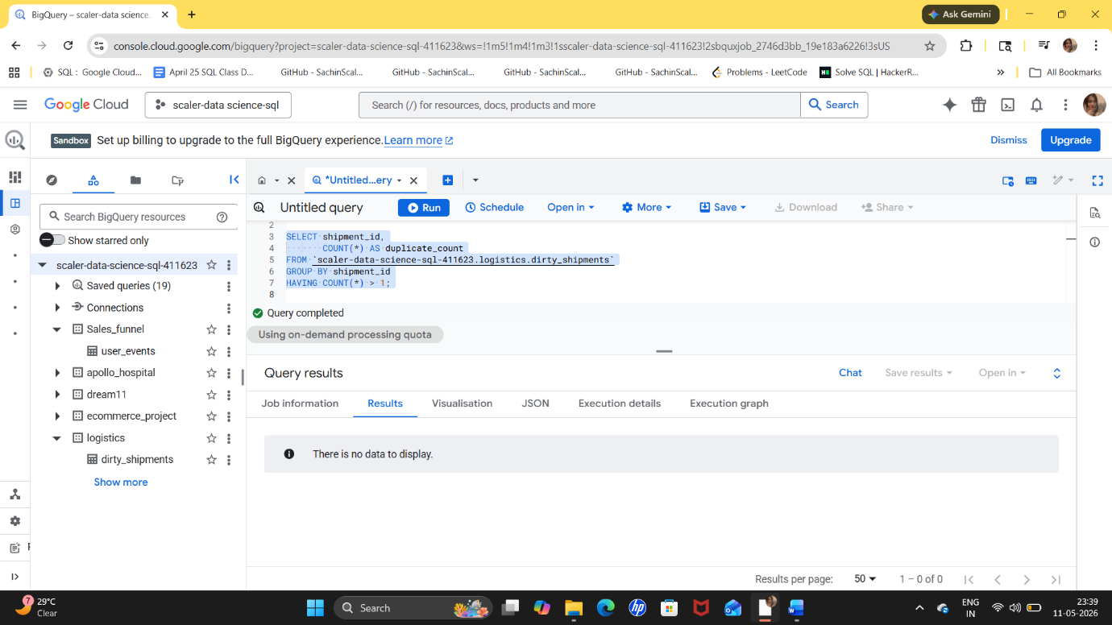
Explanation
This query identifies duplicate shipment IDs by grouping records and counting occurrences.
- GROUP BY shipment_id groups identical shipment IDs.
- HAVING COUNT(*) > 1 filters only duplicates.
Insight
Duplicate shipment records can cause:
- Incorrect revenue calculations
- Duplicate reporting
- Incorrect inventory tracking
The dataset does not contain duplicate shipment .

Question 2 — Identify Missing Values
SQL Query
SELECT *
FROM logistics.dirty_shipments
WHERE ship_date IS NULL
OR delivery_date IS NULL
OR damage_reported IS NULL;
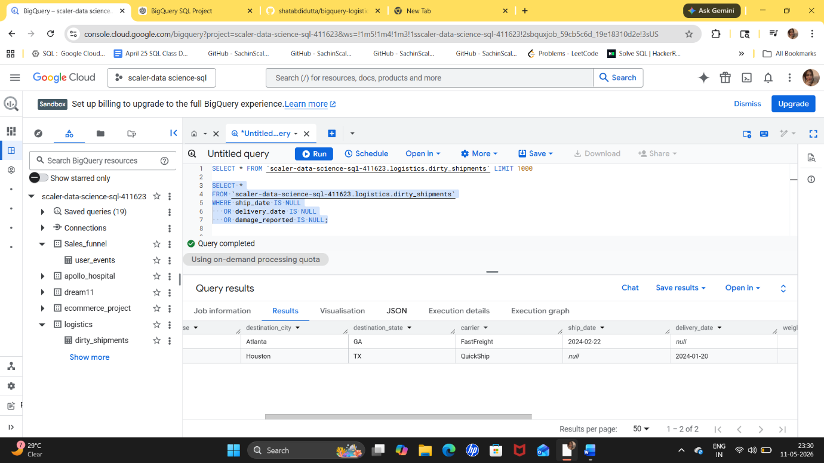
Explanation
This query identifies rows containing missing values in important operational columns.
NULL values reduce data reliability and can affect dashboards and KPIs.
Insight
The dataset contains missing shipment dates and missing delivery dates.
These records require:
- Data correction
- Imputation
- Business validation

Question 3 — Standardize Warehouse Names
SQL Query
SELECT DISTINCT origin_warehouse,
UPPER(TRIM(origin_warehouse)) AS standardized_warehouse
FROM logistics.dirty_shipments;
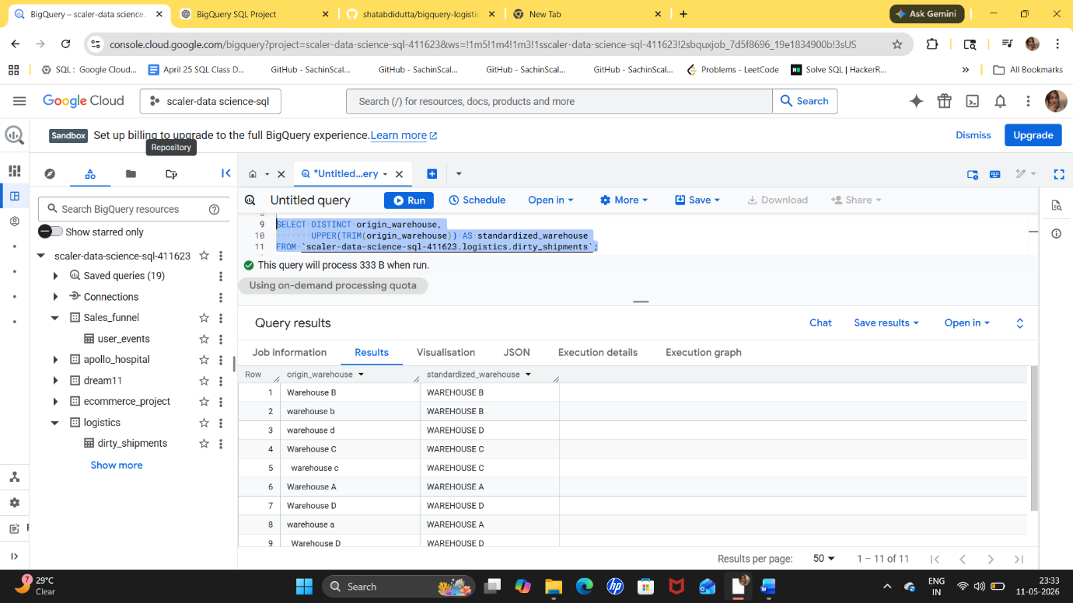
Explanation
This query cleans warehouse names using:
- TRIM() to remove extra spaces
- UPPER() to standardize capitalization
Example:
- warehouse a
- Warehouse A
Both become:
WAREHOUSE A
Insight
Inconsistent text formatting creates inaccurate grouping and reporting.
Standardization ensures consistent operational analytics.

Question 4 — Find Negative or Invalid Weights
SQL Query
SELECT shipment_id,
weight_kg
FROM logistics.dirty_shipments
WHERE weight_kg <= 0;
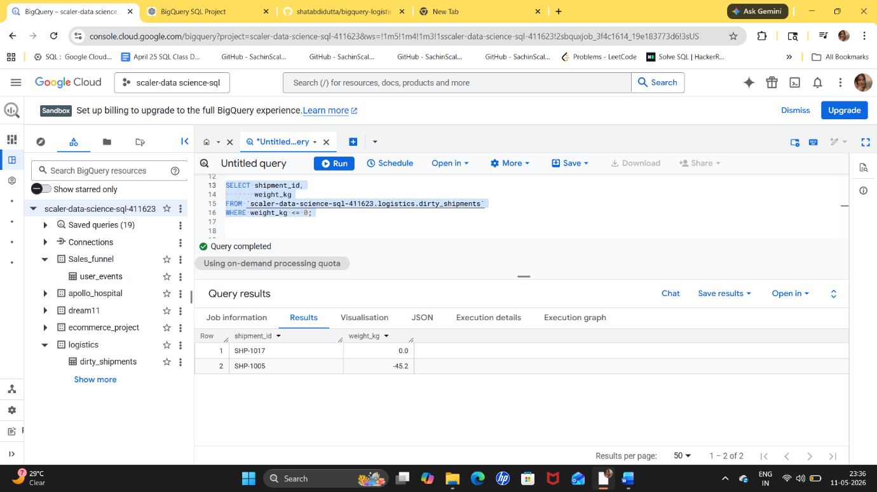
Explanation
Shipment weight cannot logically be zero or negative.
This query identifies invalid shipment weights.
Insight
Negative shipment weights indicate:
- Data entry errors
- ETL issues
- Incorrect sensor values
These records should be corrected or removed.

Question 5 — Standardize Shipment Status
SQL Query
SELECT DISTINCT shipment_status,
INITCAP(TRIM(shipment_status)) AS cleaned_status
FROM logistics.dirty_shipments;
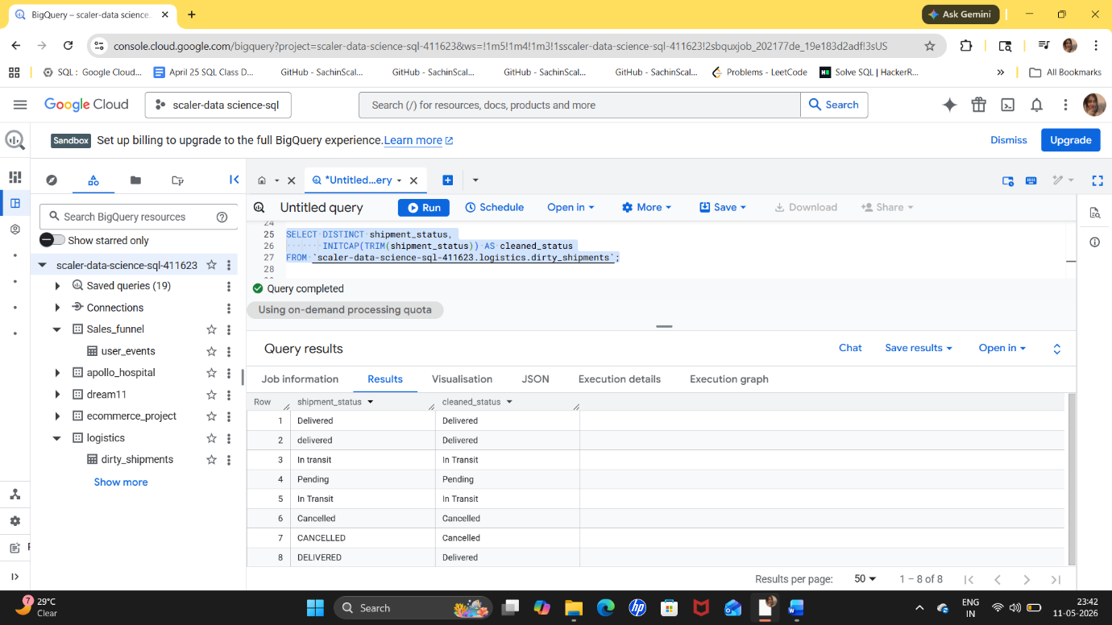
Explanation
The query standardizes shipment statuses by:
- Removing spaces
- Fixing capitalization
Examples:
- delivered
- Delivered
Both become:
Delivered
Insight
Inconsistent status values can break BI dashboards and KPI reports.

Intermediate Level Data Cleaning Questions
Question 6 — Convert String Dates into Proper Date Format
SQL Query
SELECT shipment_id,
PARSE_DATE('%Y-%m-%d', ship_date) AS cleaned_ship_date
FROM logistics.dirty_shipments
WHERE REGEXP_CONTAINS(ship_date, r'^\\d{4}-\\d{2}-\\d{2}$');
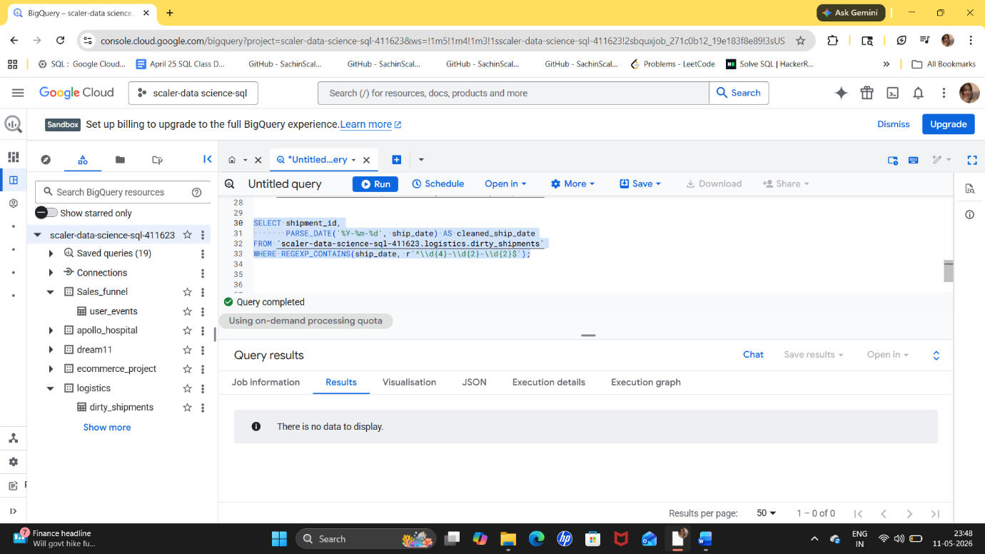
Explanation
The dataset does not contain inconsistent date formats.
This query converts string dates into Big Query DATE format using PARSE_DATE().
Insight
Standardized dates are necessary for:
- Delivery tracking
- SLA reporting
- Time-series analysis

Question 7 — Find Deliveries Completed Before Shipping
SQL Query
SELECT shipment_id,
ship_date,
delivery_date
FROM `scaler-data-science-sql-411623.logistics.dirty_shipments`
WHERE SAFE.PARSE_DATE('%Y-%m-%d', delivery_date)
< SAFE.PARSE_DATE('%Y-%m-%d', ship_date);
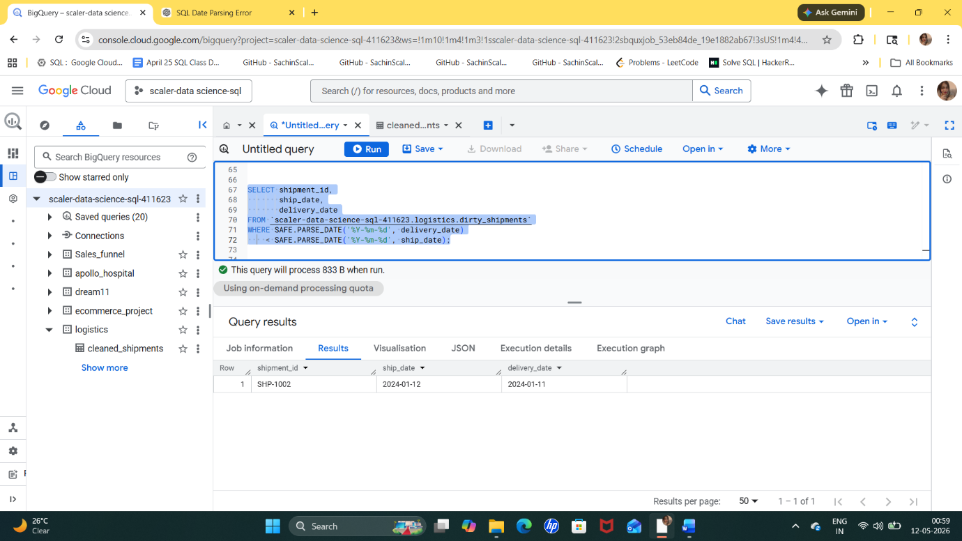
Explanation
Delivery dates should always occur after shipment dates.
This query identifies logically incorrect shipment timelines.
Insight
Such records indicate:
- Manual entry mistakes
- System synchronization problems
- Incorrect API ingestion

Question 8 — Remove Duplicate Records Using ROW_NUMBER()
SQL Query
WITH duplicates_removed AS (
SELECT *,
ROW_NUMBER() OVER(
PARTITION BY shipment_id
ORDER BY shipment_id
) AS rn
FROM logistics.dirty_shipments
)
SELECT *
FROM duplicates_removed
WHERE rn = 1;
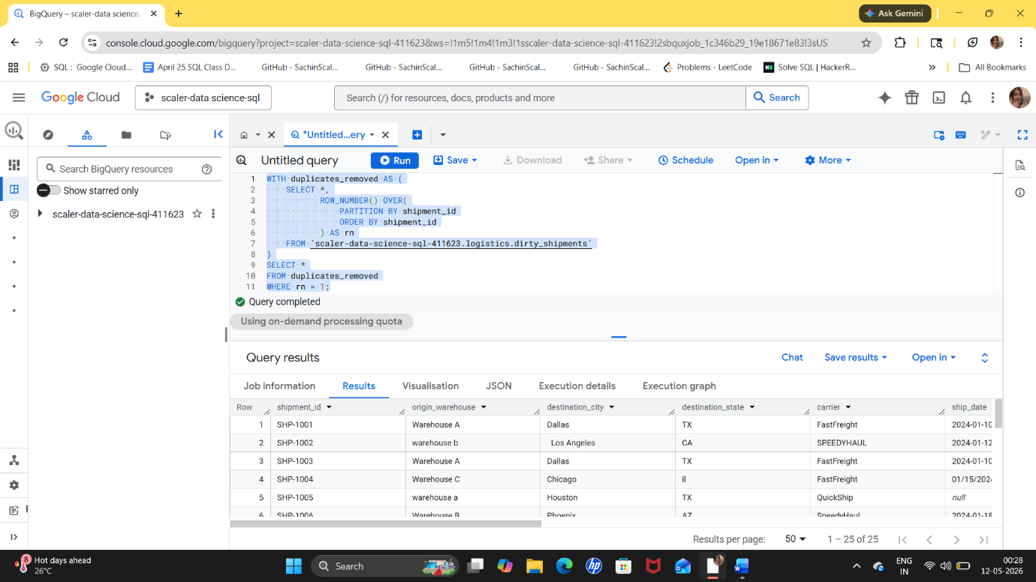
Explanation
This query:
- Assigns row numbers to duplicate shipment IDs
- Keeps only the first occurrence
- Removes duplicate rows
Insight
ROW_NUMBER() is commonly used in production ETL pipelines for deduplication.

Question 9 — Create a Fully Cleaned Dataset
SQL Query
CREATE OR REPLACE TABLE logistics.cleaned_shipments AS
SELECT DISTINCT
shipment_id,
UPPER(TRIM(origin_warehouse)) AS origin_warehouse,
INITCAP(TRIM(destination_city)) AS destination_city,
UPPER(TRIM(destination_state)) AS destination_state,
INITCAP(TRIM(carrier)) AS carrier,
SAFE_CAST(weight_kg AS FLOAT64) AS weight_kg,
SAFE_CAST(freight_cost AS FLOAT64) AS freight_cost,
INITCAP(TRIM(shipment_status)) AS shipment_status,
items_count,
INITCAP(TRIM(damage_reported)) AS damage_reported
FROM logistics.dirty_shipments
WHERE weight_kg > 0;
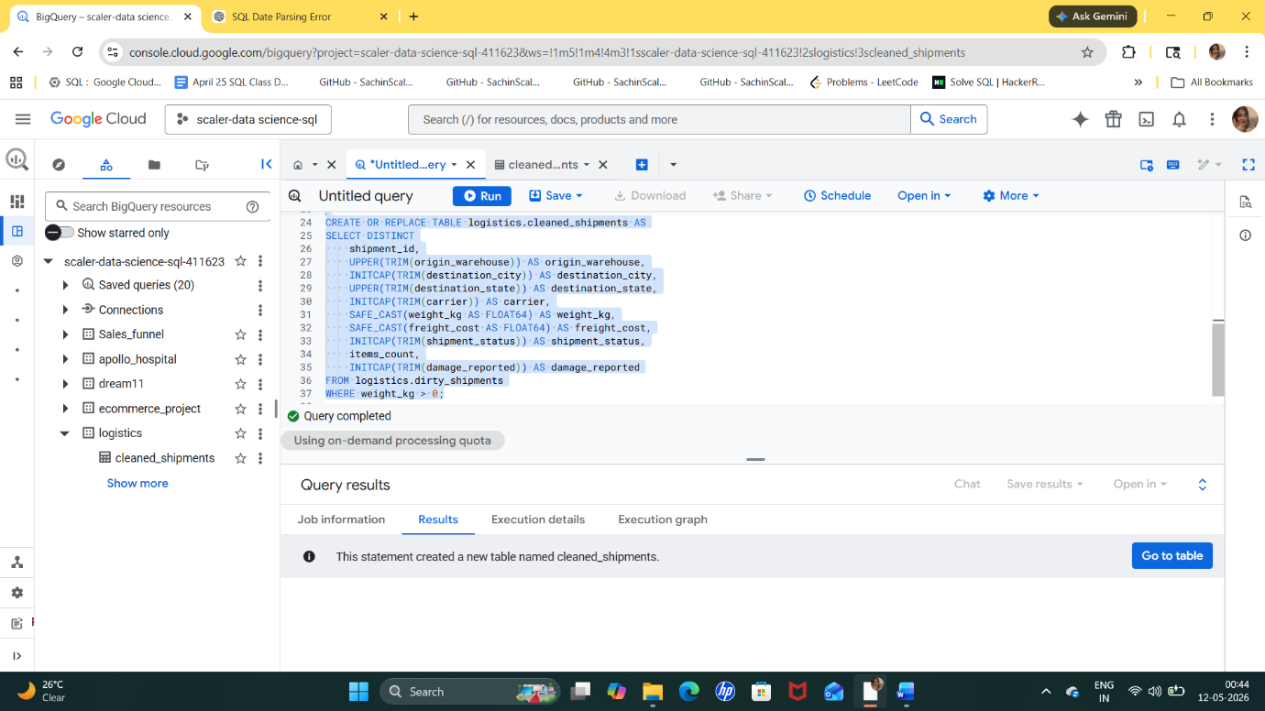
Explanation
This query performs:
- Deduplication
- Standardization
- Data type cleaning
- Removal of invalid weights
- Formatting improvements
Insight
A cleaned dataset improves:
- Reporting accuracy
- Dashboard consistency
- Decision-making reliability

Question 10 — Calculate Delivery Duration
SQL Query
SELECT shipment_id,
DATE_DIFF(
PARSE_DATE('%Y-%m-%d', delivery_date),
PARSE_DATE('%Y-%m-%d', ship_date),
DAY
) AS delivery_days
FROM logistics.dirty_shipments;
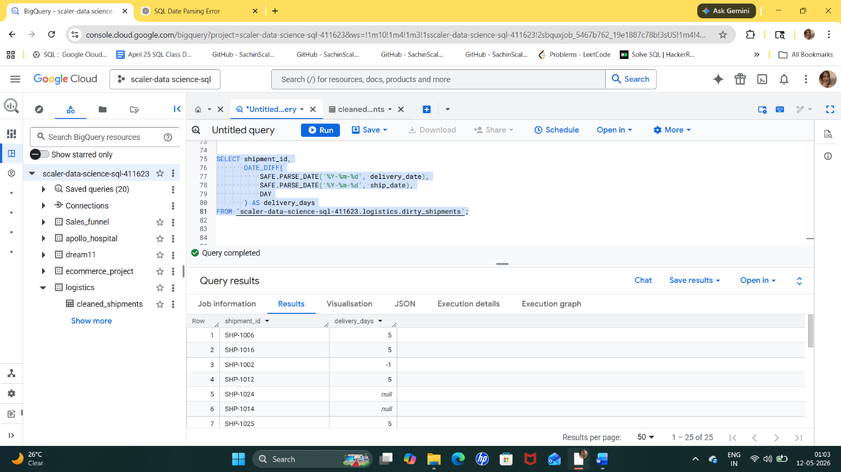
Explanation
This query calculates shipment delivery time in days.
DATE_DIFF() helps measure operational efficiency.
Insight
Delivery duration analysis helps logistics companies:
- Optimize routes
- Monitor SLA performance
- Improve customer satisfaction

Final Insights from the Project
Key Data Quality Issues Identified
Issue | Impact
Duplicate records | Incorrect reporting
Missing values | Reduced reliability
Inconsistent capitalization | Fragmented analytics
Invalid dates | Incorrect timeline analysis
Negative weights | Operational inaccuracies
Mixed status values | Dashboard inconsistency

Business Insights
After cleaning the dataset:
- Shipment tracking becomes more accurate
- Delivery KPIs become reliable
- Warehouses can be analyzed consistently
- Carrier performance can be measured correctly
- Operational anomalies become easier to detect

Conclusion
This project demonstrates how SQL and BigQuery can be used to clean operational logistics data.
The workflow reflects real-world industry practices used in:
- Supply chain analytics
- Logistics reporting
- ETL pipelines
- Data warehousing
- Business intelligence systems
The cleaned dataset can now be safely used for:
- Dashboarding
- KPI reporting
- Predictive analytics
- Operational monitoring
- Machine learning pipelines

